EASY READ DOCUMENTS

ADVOCACY
 | This document will help you understand advocacy and who an advocate is.
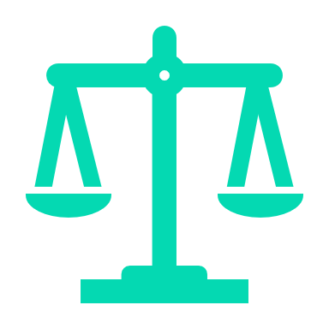 | Advocacy is when a person publicly helps to promote, provide and protect your human rights
 | Advocacy can help your voice be heard and your wishes met.  Advocacy can be used to help you become part of your community.
 | Sometimes you might find it hard to say what you want. You might want someone to:  - support you  - Speak up for you  - Be your voice.
 | An advocate can be that person.  An advocate is a person who provides a public voice for you if you cannot or do not want to speak up for yourself.
 | An advocate should be fair and treat everybody in the same way.
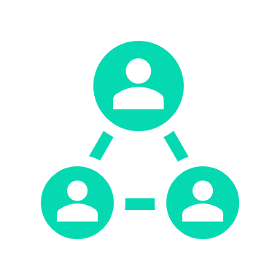 | You can ask someone you trust to be your advocate, like your:  - mum or dad  - brother or sister  - close friend.
 | Or you can ask a professional, independent advocate to help you and to be your voice.  They can help you make good decisions and choices designed for you.
 | Your advocate should always:  - listen and support you  - Take your side  - help you make your own good choices and decisions
 | Your advocate can help you:  - get ready for meetings  - Tell people/providers what you want  - By signing documents for you.
   | Importantly, your advocate can represent you and speak on your behalf.

 | Your advocate can help you make a complaint if you are not happy with the following:  - supports provided  - the way you have been treated.
 | Your advocate can speak for you and tell us how you have been mistreated.  They will help us understand the support and assistance you need.
 | Your advocate must keep your information private.
 | Not sure how to find an advocate?
 | Talk to the Client Manager at SkyCare Solutions Pvt Ltd  Call: 03 7047 9499  They will help you find an advocate.
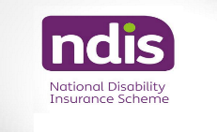 | Our Business Manager can also help you go online to use the NDIS Disability Advocacy Finder

COMPLAINTS AND FEEDBACK
 |  | This document tells you how to make a complaint or give feedback.
 |  | SkyCare Solutions wants you to give us feedback or make a complaint if you are unhappy.
 |  | It is okay to complain if you are not happy. Tell us when you are upset about:  - the support you received  - your support workers  - SkyCare Solutions Pvt Ltd

 | If you do not feel comfortable telling us about your complaint, you should tell someone you trust, like your:  - Mum or Dad  - brother or sister  - support worker.  Ask them to help you make a complaint.
 | Or you can get help from a professional, independent advocate to make a complaint or provide feedback to us.
 | We can help you find an advocate if you want.  Ask our Business Manager to help you. Call them on 03 7047 9499
 | How do you make a complaint or provide feedback to us?
 | You can talk to:  - Your support worker  - our Complaint Manager  - the Client manager.
   | You can call or email our Complaints Manager directly:  - Call: 03 7047 9499  - Email: services@skycaresolutions.com.au
 | You can fill out the Complaints and Feedback Form and mail it to the Complaints Manager:  jeewan@skycaresolutions.com.au  Ask the Complaints Manager or your support worker for a copy of the form.
 | You can fill in the participant survey we send to you every year.
 | You can make a complaint at any time directly to the NDIS Commission:  Call: 1800 03 55 44  Or go to their website: www.ndiscommission.gov.au
 | You can make a complaint and remain anonymous.  Anonymous means we will not know who you are.

   | To be anonymous, use the Anonymous Complaint and Feedback Form provided at your intake meeting:  - Complete the form (your advocate can do this for you).  - Mail it back to us using the stamped, self-addressed envelope provided.
 | Remember, if you complain anonymously, we cannot provide you with a response, as we will not know who you are.
 | We take all complaints and feedback we receive seriously.  They help us to make our service and supports better for you!

 | How do we manage your complaint or feedback?
 | Our Complaint Manager will:  - talk with you about your problem  - write everything you say down  - plan to fix your problem.
   | Our Complaint Manager will:  - Try to fix your problem  - Contact you regularly to tell you how the problem is being fixed.
 | To keep you safe, if your complaint or feedback involves someone being put in danger of being hurt, we will tell the police and the NDIS.
 | We keep everything you tell us private.

 | If you are unhappy with the way we handle your feedback or complaint, you can tell the NDIS Commission:  - Call: 03 7047 9499  (free call from a landline)  - Go to their website: www.ndiscommission.gov.au

CONFLICT OF INTEREST

 | This document explains what a conflict of interest is and what SkyCare Solutions Pvt Ltd does to manage them.
 | A conflict of interest occurs when a staff member's interests differ from SkyCare Solutions or your best interests.
 | Our staff should always do what is best for you and SkyCare Solutions.
 | Our staff's interests are called private interests.
   | A private interest can be:  - Direct – something owned by the person  - Indirect – something owned by a family member or a close friend.
 | A private interest can also be:  - financial – getting money from it  - non-financial – building personal relationships in the community or with friends and family.
 | It is okay for staff to have a conflict of interest if they tell SkyCare Solutions.  We can then decide what to do about their conflict of interest to manage it.

 | A conflict of interest may be:  - actual – it happened  - potential – it could become a problem  - perceived – it seems like a conflict, but is okay as long as it is monitored.
 | A conflict of interest is wrong when a staff member uses it to get more than they should for themselves or their friends.
 | A conflict of interest can happen if a staff member's close friends or family members become involved in work decisions.
 | A conflict of interest can happen if a staff member gets extra money by working for a different company while working at SkyCare Solutions.
   | A conflict of interest happens when our staff:  - are involved with another organisation  - encourage you to use the other Provider to receive supports.
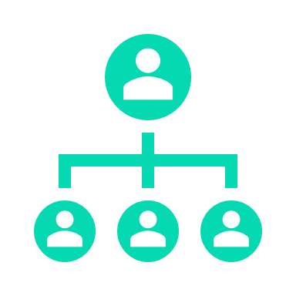 | How does SkyCare Solutions manage a staff conflict of interest?
 | We ask all of our staff to tell us (declare) their conflict of interest as soon as possible.
 | Our Business manager assesses all staff conflicts of interest to make sure they will not severely impact our organisation or you in any way.
 | Our Business manager will manage and monitor all declared conflicts to ensure they continue not to impact you or us.
   | We regularly check that conflicts of interest are not impacting SkyCare Solution's:  - support provision  - quality of support  - good decision-making
 | How do we ensure no conflict of interest with a participant?
 | Our Business manager will discuss any identified conflicts of interest that could impact the support you receive.
   | Our Business manager will explain how we manage the conflict.
 | We want you to tell us if you are unhappy about managing the conflict of interest.
 | We will work with you to try and make changes to make you happy.
 | Any decisions you make about your providers or supports will not impact the current supports we provide you.
 | Using other providers will not impact the quality of supports you receive from SkyCare Solutions.
 | If we cannot fix the conflict of interest and are unhappy, we may refer you to another provider.
   | We will talk with you about this.  We will work out the best way for you to continue receiving the supports you need.
 | If you are referred to another provider, we will assist with your transition from our service.

Incident Management
 | This document tells you what an incident is and how SkyCare Solutions manages them.
 | There are two types:  - A general incident  - A reportable incident.
 | A general incident is:  - When a person causes you harm or could have caused you harm  - when you hurt someone else  - when you feel that someone is hurting you.

 | A reportable incident is when one of the following happens:  - a death  - A serious injury  - abuse  - neglect  - sexual misconduct  - unregulated use of restrictive practices.
   | If you are involved in an incident, you must immediately tell our Client manager, your support worker or a trusted person.
 | Our Client manager will meet with you to record what was said and done during the incident.
 | Our Client Manager will ask you:  - What happened  - the names of people who saw the incident  - When you told someone about the incident (date and time)  - details of the person you told  - How the incident affected you  - What could be done to stop the incident from happening again?
 | Your safety is important to us.  After an incident, we will provide support or assistance to help you recover from the incident.

 | After an incident, SkyCare Solutions will:  - do all we can to make sure you are safe  - provide you with advice and support  - arrange for counselling or medical support (if required).
 | We will support you by:  - fixing the incident quickly  - helping you look after your health and well-being (where we can).
 | We will regularly keep you up to date with how we are managing the incident.

   | The Client Manager will contact you to:  - talk about what happened  - Tell you what actions we will take to fix the incident  - Explain to you what actions have already been taken.
 | We will ask for your:  - feedback and thoughts on how we are fixing the problem  - ideas about any changes that could help you in the future.
 | Our Client Manager investigates the incident to work out what happened and stop it from happening again.
 | We then completed a review of the incident to improve our service by:  - Learning what happened  - making changes to stop it from happening again.
 | Some changes we might make could be to:  - Change our practices  - change our policies  - retrain our staff.
 | Reportable incidents
 | A reportable incident is when you or another participant is badly hurt or mistreated.
 | SkyCare Solutions must tell the NDIS Commission if a reportable incident happens.
 | We must complete an NDIS Reportable Incident Form.  - Immediate Notification Form  - 5-Day Notification Form.
 | must send the form to the NDIS Commission using the NDIS portal.
 | The NDIS Commission reviews the incident.  They will tell us if we need to take any further action.

 | We will update you on the NDIS Commission's findings, including any actions we must take.
   | We keep everything you tell us privately.
 | If you are unhappy with the way we handle your incident, you can tell the NDIS Commission:  - Call: 1800 03 55 44 (free call from a landline)  - Go to their website: www.ndiscommission.gov.au

Money and Property
 | This document tells you how we will look after your money and property.
 | You are the owner of your money and property.  If you say it is okay, we can help you buy things with your money, and we will use your property to deliver your services.
   | We can only use your money or property if you have agreed, and it is written in your Service Agreement and Support Plan.
 | You agree to our staff helping you use by completing the Participant Money and Property Consent Form.
 | Property:  - Our staff will only use your property if needed to help deliver your services.  - It would be best if you told us it is okay to use your property.  - We will add a list of properties that can be used in your Support Plan.
 | Money:  - You tell us how you want to spend your money.  - Our staff cannot touch your money without permission.
 | If you ask a support worker to help you spend your money, they must check if they can with our Client manager.
   | Our staff cannot use your PIN or get money from an ATM because this is your VERY private information.
 | If a support worker helps you with your money, they must follow our rules to keep you and your money safe.
 | Our staff will keep all receipts for things they have used your money to buy.  They will keep a record of all of your money that has been spent.

 | Staff will count out your money with you before buying something.  They will count out your change after buying something.  You will both sign a record agreeing your money was correctly spent.
 | SkyCare Solutions will tell you how and when your money was spent every month.
 | Our staff cannot give you any advice or information about money matters.
   | If we think someone is misusing your money or property, our Client manager will tell you.
   | The Business Manager will:  - investigate, record evidence and write a report  - Tell the police or other authorities, if needed  - provide additional support to you (if needed).
 | If you want help after the Service Agreement is written, we will:  - Talk to you about the help needed  - Write everything in your notes.

 | The Business Manager will then:  - Include the help you need in your Service Agreement and Support Plan and give you an updated copy.
 | If you are unhappy with how we manage your money or property, you can tell the NDIS Commission:  - Call: 1800 03 55 44 (free call from a landline)  - Go to their website: www.ndiscommission.gov.au

Privacy and Your Personal Information
 | This document tells you about your privacy and your personal information.
 | To help us provide you with the proper support and services, we collect and store personal information about you.
 | We use your personal information to work with you to design supports and care that meets your needs.

 | Personal information can include:  - your name, address and phone number  - your advocate's contact details  - details about people who you are close to (mum, brother or a good friend)  - supports you need  - your medical records  - Other support providers you use  - Why and how we are helping you.
 | It is SkyCare Solutions 's responsibility to keep your personal information private and safe.
 | We only share our information with others if you say "yes" or if the law says we must.
 | You can say 'no' when asked to share your information with government agencies (like the NDIS).  This instruction means you opt out of sharing your personal information.
   | We will ask you to sign an information consent form.  The form gives us your approval to use your personal information.
 | We also ask you to include all the people with whom you are happy to share your personal information on the form.

 | Your information will only be shared with people who you have said can see it, like:  - an advocate  - a trusted person  - other support providers  - support workers  - government organisations that support you.
 | You have rights when it comes to the management of your personal information.

 | You can:  - Ask our Business Manager to see your personal information at any time  - Tell us to correct wrong or incomplete information  - Tell us if you think the information is wrong and must be deleted

Participant's Rights
 | This document tells you about your rights.
 | Australian laws respect the rights of people with disabilities. The laws tell you:  - should be included in community life, and  - have the same rights as all other Australians.
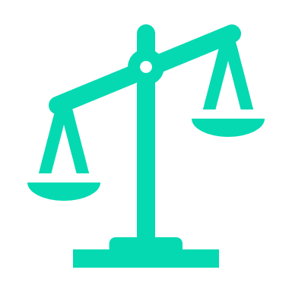 | What are your human rights?
 | You should be:  - safe in your home and anywhere else  - treated with respect  - part of your cultural community.
 | You should be able to:  - participate in your religion  - express your sexuality  communicate in your family's language.
 | You also have rights when working with SkyCare Solutions and other disability support providers.

 | You have the right to:  - receive good-quality services  - Tell us what you want  - Choose the type of support worker you want  Make your own choices.

 | You also have the right to:  - Be safe  - get help when you need it  - try new things and take risks.
 | How does SkyCare Solutions respect your rights?
 | SkyCare Solutions will:  - Keep you safe  - show you respect and respect your privacy  - treat you well  - help you make your own choices  - listen to you  - involve your family, advocates and other support carers (if you want us to).
 | We will also:  - ask you to tell us what supports you want and the type of worker you need  - Keep your personal information private.
 | We can also help you find an advocate if you need one.
 | You can safely:  - Make complaints and provide feedback to us  - Tell us you want to use another provider.
 | We will follow your instructions unless we feel that you may get hurt.  We will then talk to you and your advocate/family about any risks to help you make a safe decision.
 | We also make sure our support workers follow our Service Charter of Rights.

What is a Service Agreement?
 | This document tells you what a Service Agreement is and why you need one.
 | A Service Agreement is a document.  It is an agreement between you and your service provider.  The service provider is the person or organisation supporting you (like SkyCare Solutions).
 | When you agree on the services you want from the Provider, it is written down in the Service Agreement.
 | The Service Agreement says that you and your Provider agree to the services they will provide.
 | To show that you agree, you sign the Service Agreement.  We (the Provider) will also sign the agreement
 | The Service Agreement helps ensure you receive the services that are right for you.
 | Your Service Agreement is helpful because it provides everything agreed to in writing.
 | If you need help entering a Service Agreement, you can ask a trusted person to support you.  A trusted person might be a family member, your carer, a friend or an independent advocate.
 | Your trusted person (advocate) can speak on your behalf.
 | Your trusted person (advocate) can sign your Service Agreement for you (but only if you say that is okay).
 | What information should be in a Service Agreement?
 | We will meet with you and ask you to discuss the support you want.
   | We want you to tell us the following:  - What type of supports do you need  - How do you want your supports provided  - the type of support worker you want to work with  - when you need supports  - How long will you need the supports.
 | We will talk to you about the following:  - the supports we can provide  - your rights and responsibilities  - our responsibilities  - Anything special that we must consider?
 | It is a good idea to bring a copy of your NDIS Plan to your Service Agreement meetings.  (If you want, we can put a copy of your Plan in your Agreement.

 | Once we both have agreed on support and costs, we will write the Service Agreement.  We will then provide two copies for you to read and sign.
 | The Service Agreement will include what is expected from you and us (our responsibilities).
 | We will explain our responsibilities to you.  We will explain the responsibilities which you must meet.
 | The Service Agreement will include information about costs.  It will include how much our service will cost you.
 | When do you sign the Service Agreement?
 | After you or your trusted person has read the Service Agreement.
 | After you or your trusted person has had your say and is happy that the Service Agreement meets your needs.
 | You only sign the Service Agreement if you agree with what is written in it.  There will be two copies to sign (one for you and one for us).
 | You sign the Agreement, and then we will sign it.
 | We will give you a copy of your Service Agreement, and we will keep a copy in your file.
 | Do not forget to keep your copy in a safe and private place.

 | You can change or end your Service Agreement with us.  Just talk to our Business Manager to change an agreement.
 | To end the agreement, tell us in writing (if you can).  Please give us the right amount of notice (check what is written in your Service Agreement).
 | We will provide you with the support you need to leave our service.

Zero Tolerance - Violence, Abuse, Neglect and Exploitation
 | This document shows how SkyCare Solutions prevents or manages violence, abuse, neglect and exploitation.
 | You have the right to enjoy a life free from violence, abuse, neglect and exploitation.
 | You should always feel safe when receiving supports from us.  If you feel unsafe, tell our Client Manager immediately.
 | Violence is when someone hurts you physically (like hitting, punching or slapping you).
 | Abuse is when someone mistreats you and hurts your body or your feelings.
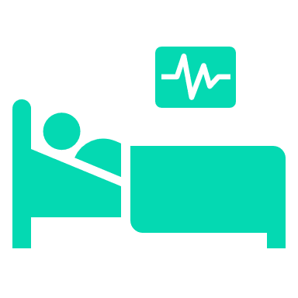 | Neglect is when someone is not caring for you or helping you how they are supposed to.
 | Exploitation is when someone is taking advantage of you.
 | SkyCare Solutions does not allow any acts of violence, abuse, exploitation or neglect towards you.
 | It is our responsibility to protect you and keep you safe.
 | We want you to tell us if someone hurts you or does not feel safe with someone.
 | If you do not feel comfortable telling us, you should tell someone you trust, like your:  - mum or dad  - brother or sister  - support worker.
 | Or you can get help from a professional, independent advocate.
 | We can help you find an advocate if you want.  Ask our Business Manager for help. Call 03 7047 9499.
 | You can also get help by calling the  National Disability Abuse Hotline on 1800 880 052.
 | To keep you safe, we will:  - Make sure our staff follow the rules  - train staff on how to help you  - Keep your information private.
 | SkyCare Solutions will always:  - support you if something terrible happens  - Call the police if we need to.
 | We will always:  - listen to you or your advocate  - provide you with the support you need  - keep you updated on what is going on.
 | If you are not happy with how we are helping you, tell the NDIS Commission: Call 1800 03 55 44  Go online to www.ndiscommission.gov.au

